Assignment 7.4
Name: Zobiya Fatima
Hall TIcket: 2303A51879
Batch No: 14

Lab 7: Error Debugging with AI – Systematic Approaches to Finding and
Fixing Bugs

Task 1: Debugging a Recursive Calculation Module Scenario
You are maintaining a utility module in a software project that performs mathematical computations. One function is meant to calculate the
factorial of a number, but users are reporting crashes or incorrect outputs.

Task Description
You are given a Python function intended to calculate the factorial of a number using recursion, but it contains logical or syntactical errors (such as a missing base condition or incorrect recursive call).
Use GitHub Copilot or Cursor AI to:
• Analyze the faulty code
• Identify the exact cause of the error
• Suggest and apply corrections to make the function work correctly
Document how the AI detected the issue and what changes were made.

Expected Outcome
• A corrected recursive factorial function
• AI-generated explanation identifying:
• The missing or incorrect base case
• The corrected recursive logic
• Sample input/output demonstrating correct execution

A Faulty Code:
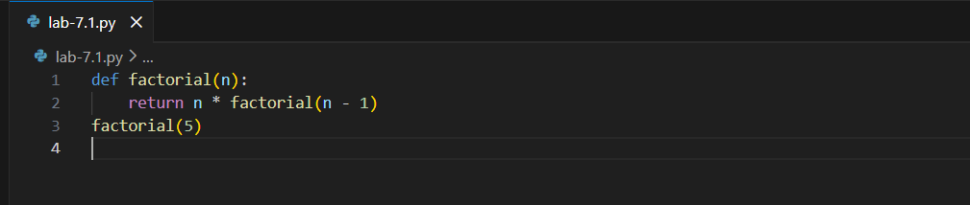
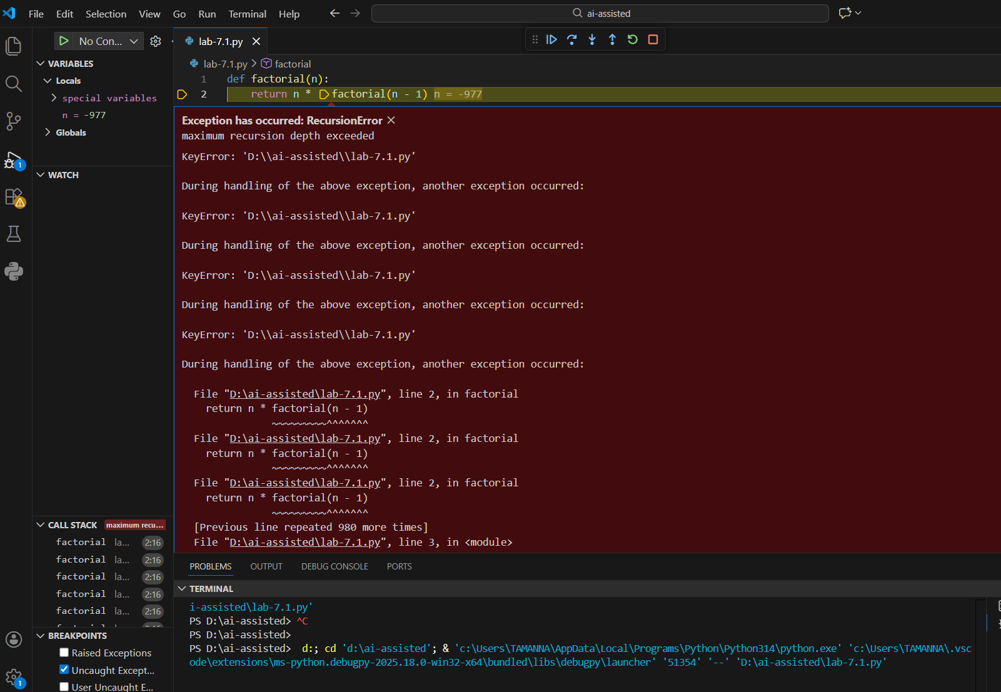

Prompt: Rectify the code and give a proper working code.
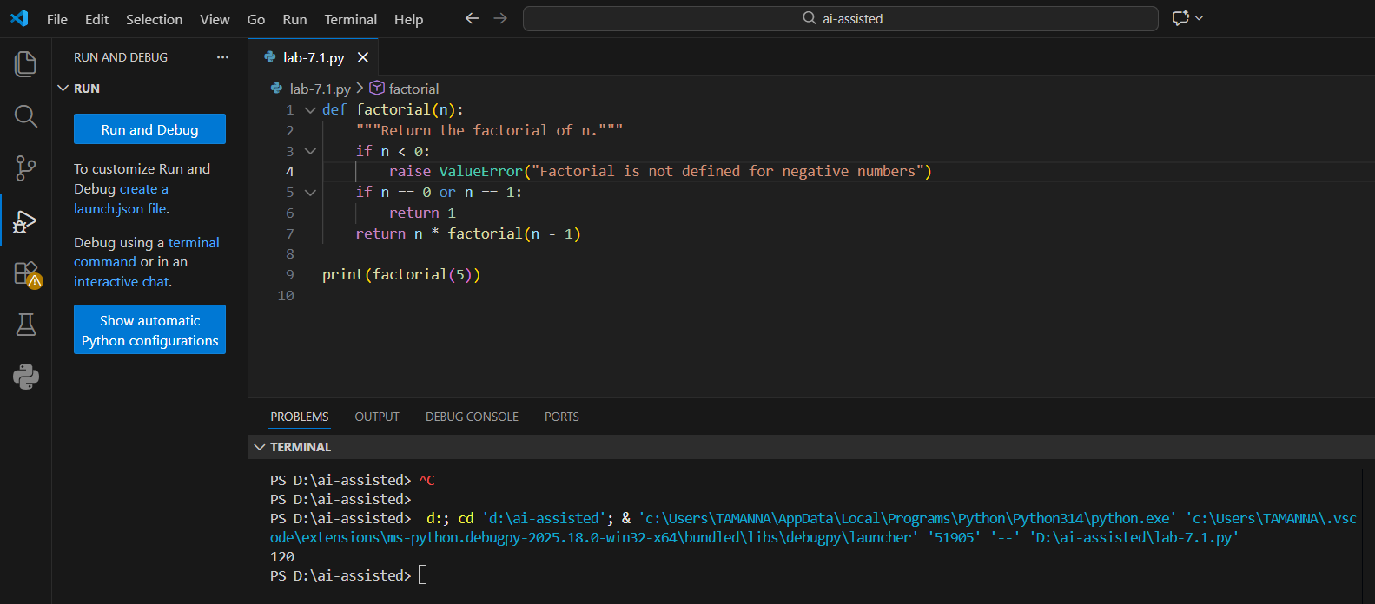
Summary:
- The faulty code was missing a base case, causing infinite recursive calls and a Recursion Error.
- The corrected code adds proper base conditions (n ==0 or n == 1) to stop recursion safely.
- An additional validation was included to handle negative inputs by raising a clear error.
Task 2: Fixing Data Type Errors in a Sorting Utility

Scenario
You are developing a data processing script that sorts user input values. The program crashes when users enter mixed data types.

Task Description
You are provided with a list-sorting function that fails due to a TypeError caused by mixed data types (e.g., integers and strings).
Use GitHub Copilot or Cursor AI to:
• Detect the root cause of the runtime error
• Modify the code to ensure consistent sorting (by filtering or type conversion)
• Prevent the program from crashing
Explain the debugging steps followed by the AI.

Expected Outcome
• A corrected sorting function
• AI-generated solution handling type inconsistencies
• Successful sorting without runtime errors
• Explanation of how the fix improves robustness

Incorrect Code:
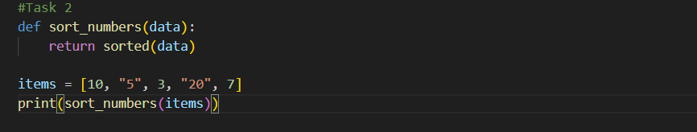
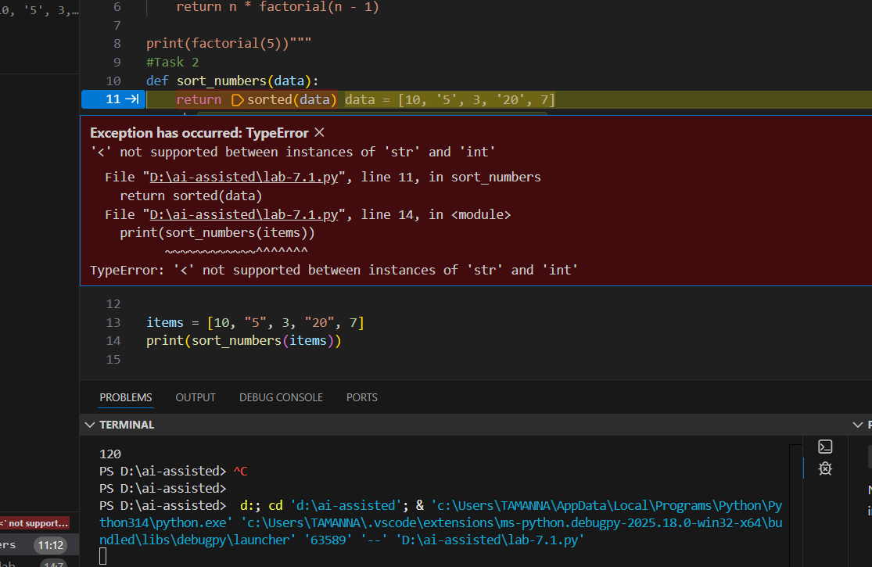

Prompt: Rectify the faulty code and give a correct one with user input
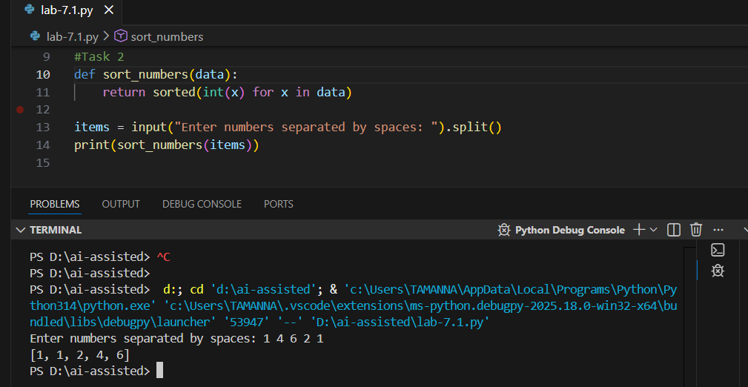

Error Explanation:
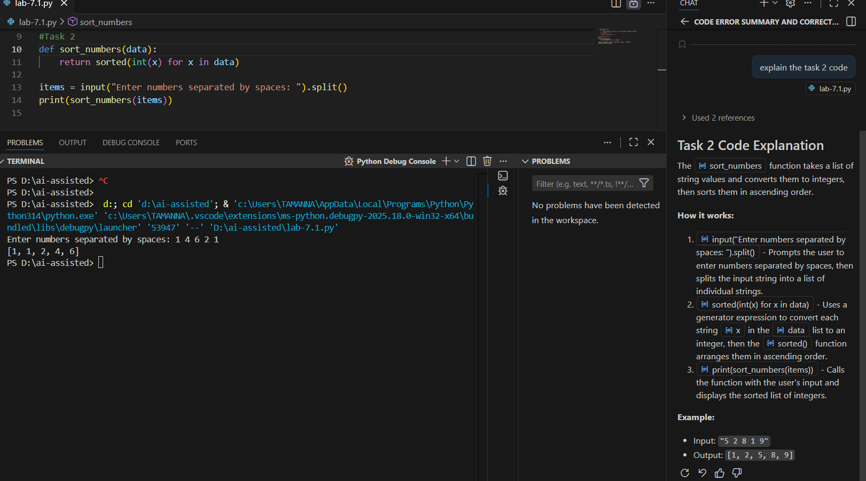
Summary:
- The faulty code failed because it attempted to sort a list containing both strings and integers, which caused a Type Error during comparison.
- The corrected code converts every input value to an integer before sorting, ensuring all elements are of the same data type.
- This change prevents runtime crashes and guarantees consistent, correct numerical sorting.
Task 3: Improving File Handling Reliability

Scenario
A backend script reads data from files regularly. Over time, the system shows performance issues due to improper resource management.

Task Description
You are given a Python file-handling snippet that opens a file but does not explicitly close it.
Use GitHub Copilot or Cursor AI to:
• Identify the potential problem in the code
• Refactor it using best practices (such as a context manager)
• Ensure safe and reliable file handling
Briefly describe why the revised approach is better.
Expected Outcome
• Refactored code using the with open() statement
• AI explanation highlighting prevention of resource leaks
• Clean execution without warnings or errors

Faulty Code:
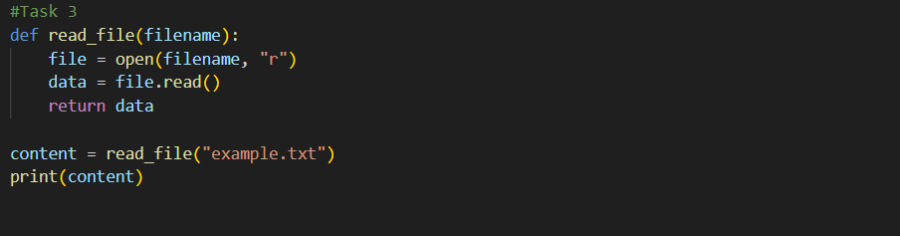

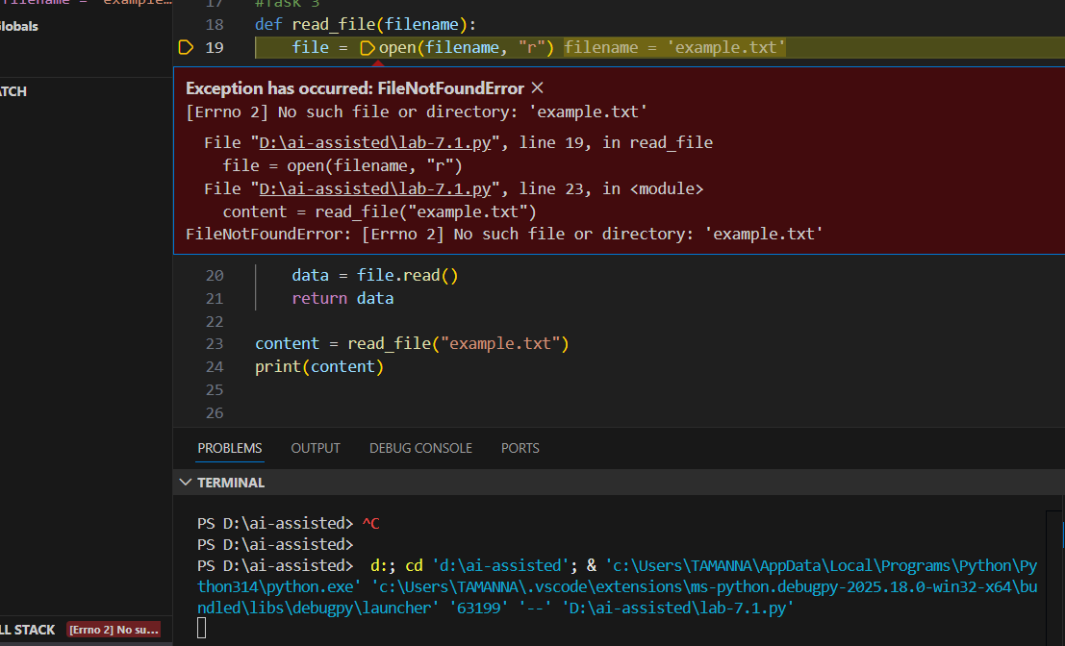

Prompt: Identify the potential problem in the code and refactor it ensuring safe and reliable file handling.
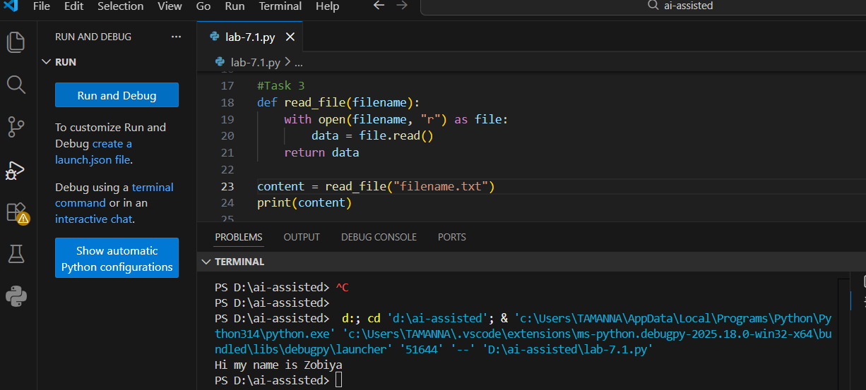

Error Explanation:
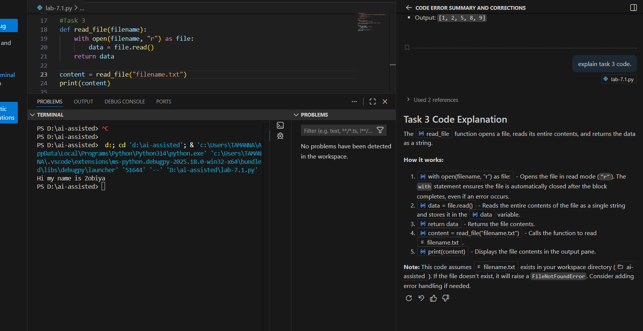

Summary:
- The faulty code opened a file using open() but did not close it, which could cause resource leaks if the program runs for a long time or crashes.
- The corrected code uses a With context manager to ensure the file is automatically closed after reading.
- This change guarantees safe, reliable file handling even if an error occurs during file operations.
Task 4: Handling Runtime Errors Gracefully in Loops
Scenario
You are working on a data analysis script that processes a list of values. Some values cause runtime errors, but the program should continue processing remaining data.

Task Description
You are provided with a code snippet containing a ZeroDivisionError inside a loop.
Use GitHub Copilot or Cursor AI to:
• Detect the exact location of the error
• Add appropriate exception handling using try-except
• Ensure the loop continues executing safely
Document how AI improved the fault tolerance of the program.

Expected Outcome
• Updated code with proper exception handling
• Meaningful error messages instead of program crashes
• Successful execution for all valid inputs

Faulty Code:
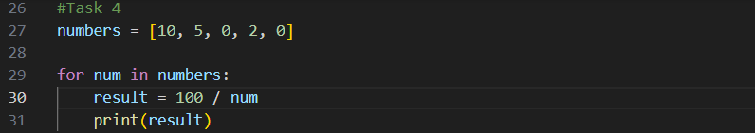

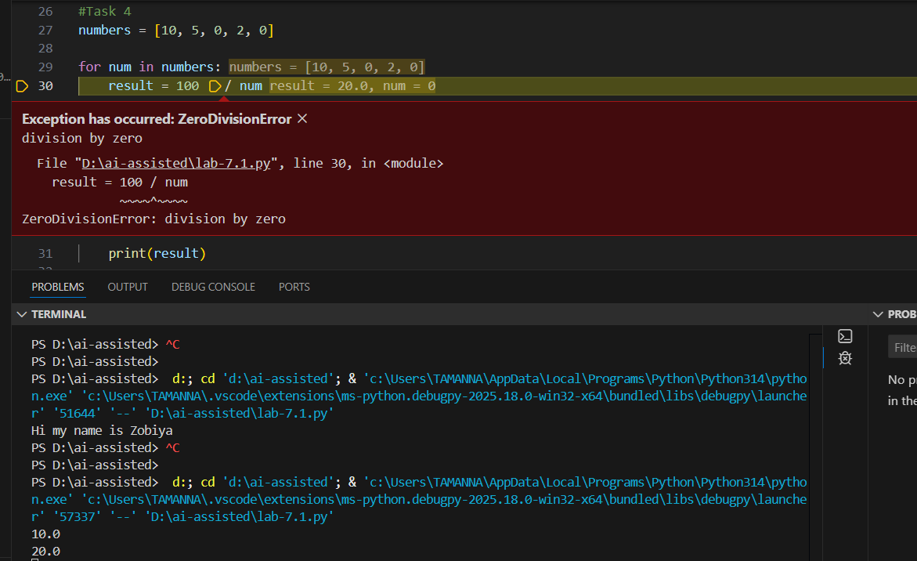
Prompt: Rectify this code and give a correct version of it.
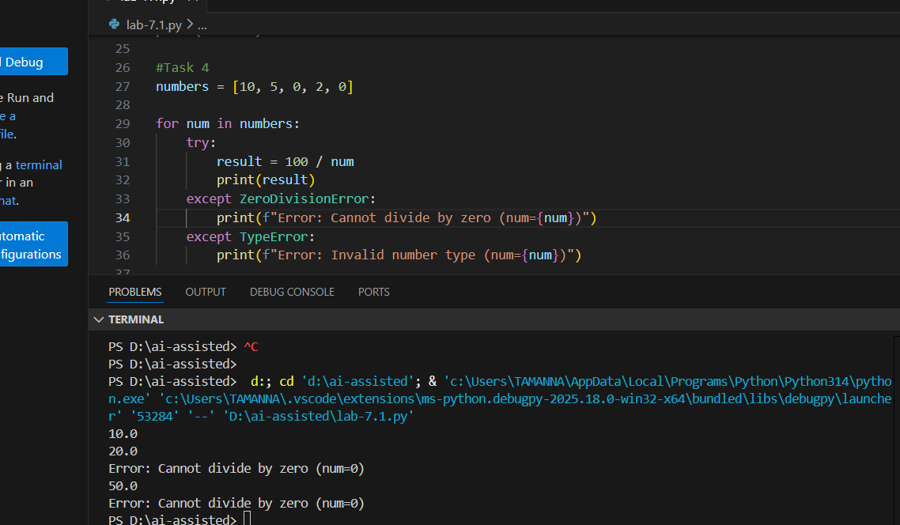

Error Explanation:
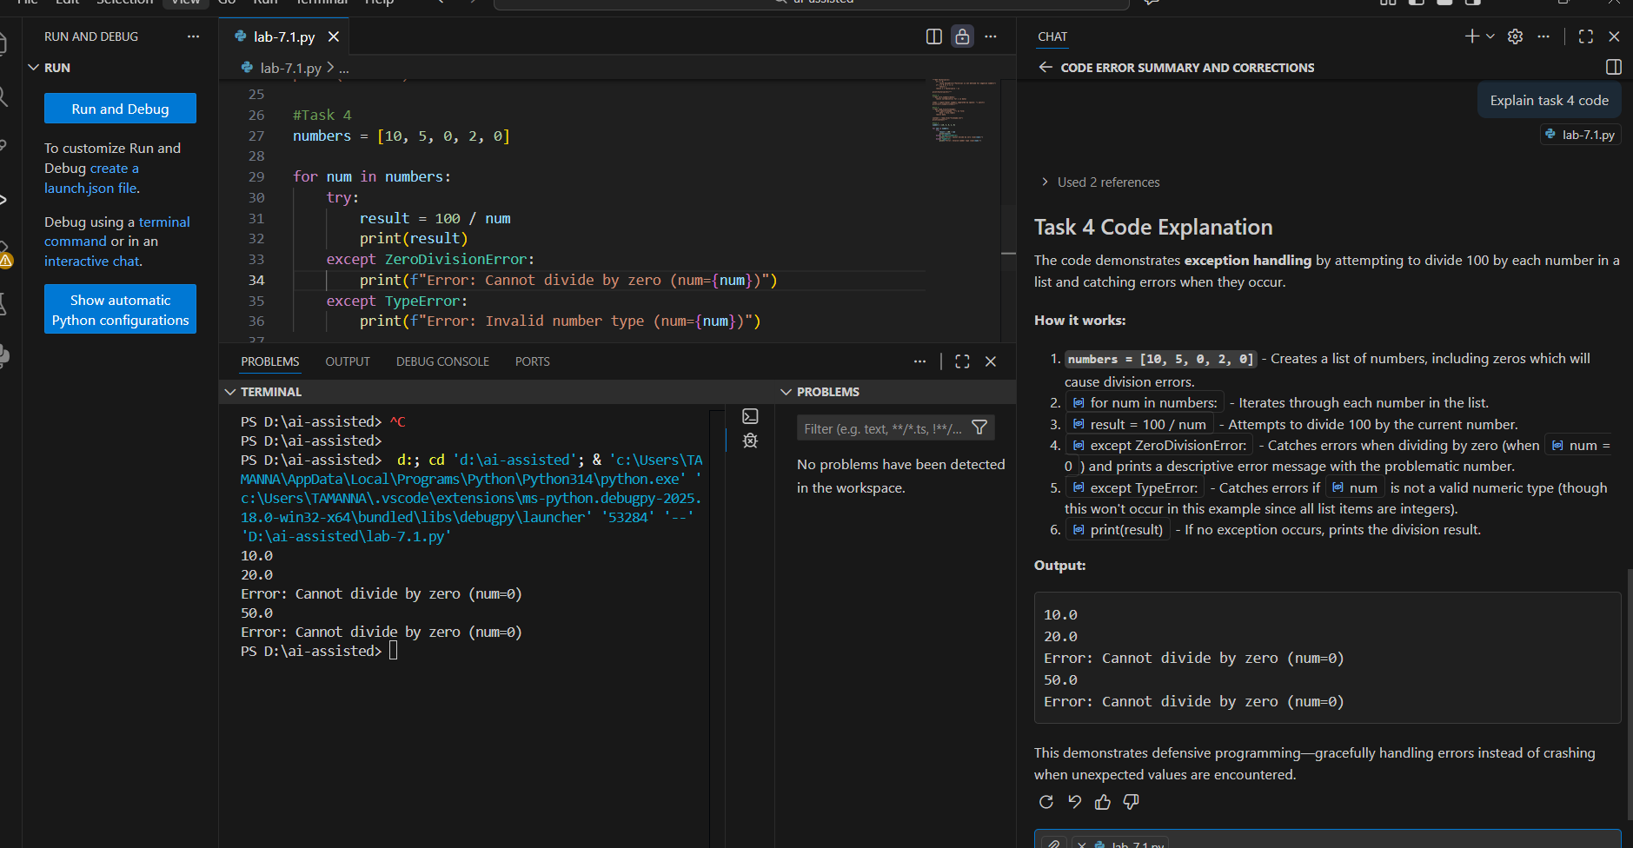
Summary:
- The original issue occurred when the loop attempted to divide by zero, causing a ZeroDivisionError and stopping execution.
- The updated code uses try-except blocks to catch division-by-zero and type-related errors at the exact failure point.
- This ensures the loop continues running safely while reporting errors instead of crashing.
Task 5: Debugging Class Initialization Errors
Scenario
A class written by a junior developer is throwing unexpected errors when objects are created or attributes are accessed.

Task Description
You are given a Python class with:
• Incorrect __init__ parameters
• Missing or incorrect attribute references (e.g., missing self)
Use GitHub Copilot or Cursor AI to:
• Analyze the class definition
• Identify constructor and attribute issues
• Correct the class so objects initialize and behave correctly
Explain the corrections suggested by the AI.

Expected Outcome
• A corrected class definition
• Proper use of self and constructor parameters
• AI-assisted explanation of the original errors and fixes
• Sample object creation and method usage

Faulty Code:
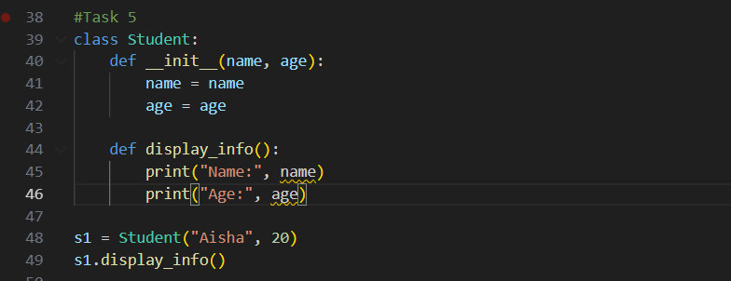

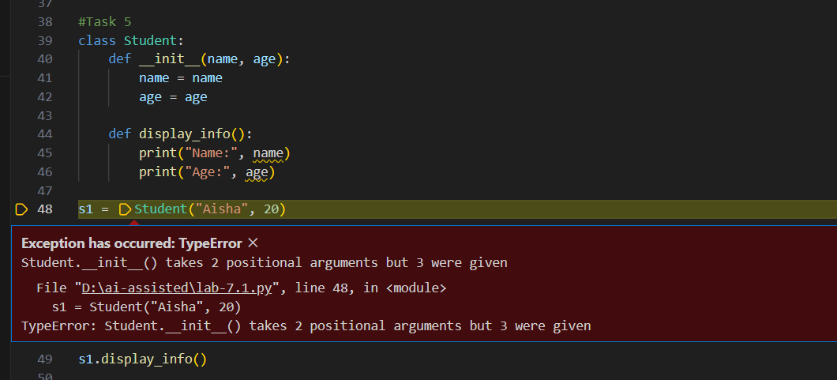

Prompt: Identify constructor and attribute issues and give a correct class definition with user input.
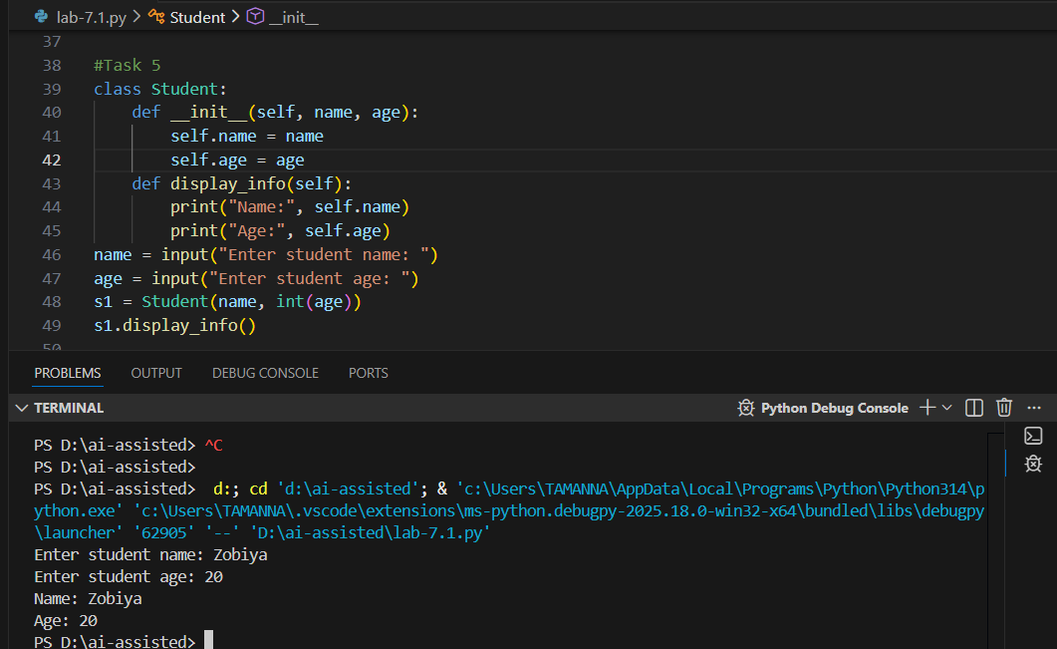

Error Explanation:
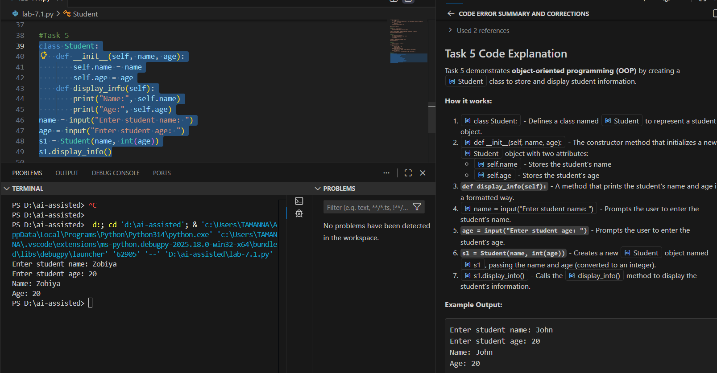
Summary:
- The class correctly defines the constructor using self to initialize object attributes name and age.
- User input is taken and the age is converted to an integer before creating the student object.
- The display_info method accesses instance attributes via self, ensuring the object behaves as expected.

